 | School of Engineering & Technology
 | Department: SOET | Session: 25-26 Even
 | Program: B. Tech CSE | Semester: IV
 | Course Code: ENCS254 | Name: Vandana Sharma  Roll No: 2401010285
 | Course Name: Database Management Systems Lab | Faculty: Ms. Santosh Rani

Lab Sheet: 3

Objectives

- To understand the use of COMMIT and ROLLBACK commands in transaction control.
- To use ORDER BY and GROUP BY clauses in SQL queries.
- To understand DCL commands (GRANT, REVOKE) and the use of SAVEPOINT.
- To understand and implement JOIN operations in SQL.

Instructions

Open your preferred Database Management System (DBMS) tool.

- Create the required tables: TEACHER, SALES, DEPARTMENTS, and EMPLOYEES.
- Insert suitable records into each table.
- Execute the SQL commands for transaction control, privilege control, grouping, sorting, and joins.
- Observe the output after each operation such as ROLLBACK, COMMIT, SAVEPOINT, GRANT, and REVOKE.

DDL Questions (Data Definition Language)

- Create the TEACHER table with the following attributes:
(Name, DeptNo, Date_of_Joining, DeptName, Location, Salary).
- Create the SALES table with the following attributes:
(Sales_No, Salesname, Branch, Salesamount, DOB).
- Create the DEPARTMENTS table with the following attributes:
(dept_no, dept_name, dept_location).
- Create the EMPLOYEES table with the following attributes:
(emp_id, emp_name, emp_salary, dept_no).

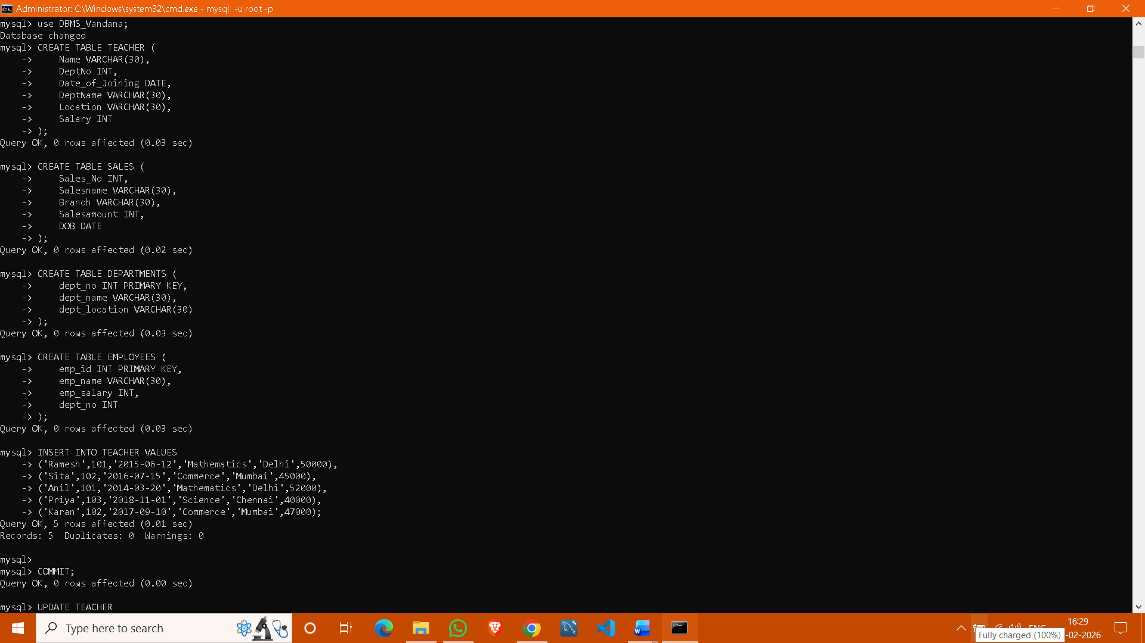

DML Questions (Data Manipulation Language)

From TEACHER Table

- Insert five records into the TEACHER table.
- Give an increment of 25% salary to teachers working in the Mathematics department.
- Give an increment of 15% salary to teachers working in the Commerce department.

From SALES Table

- Insert five records into the SALES table.
- Calculate the total sales amount in each branch.
- Calculate the average sales amount in each branch.
- Display the Salesname and DOB of salesmen born in the month of December with date format like 21-Dec-09.
- Display the Salesname and DOB of salesmen in alphabetical order of the month.



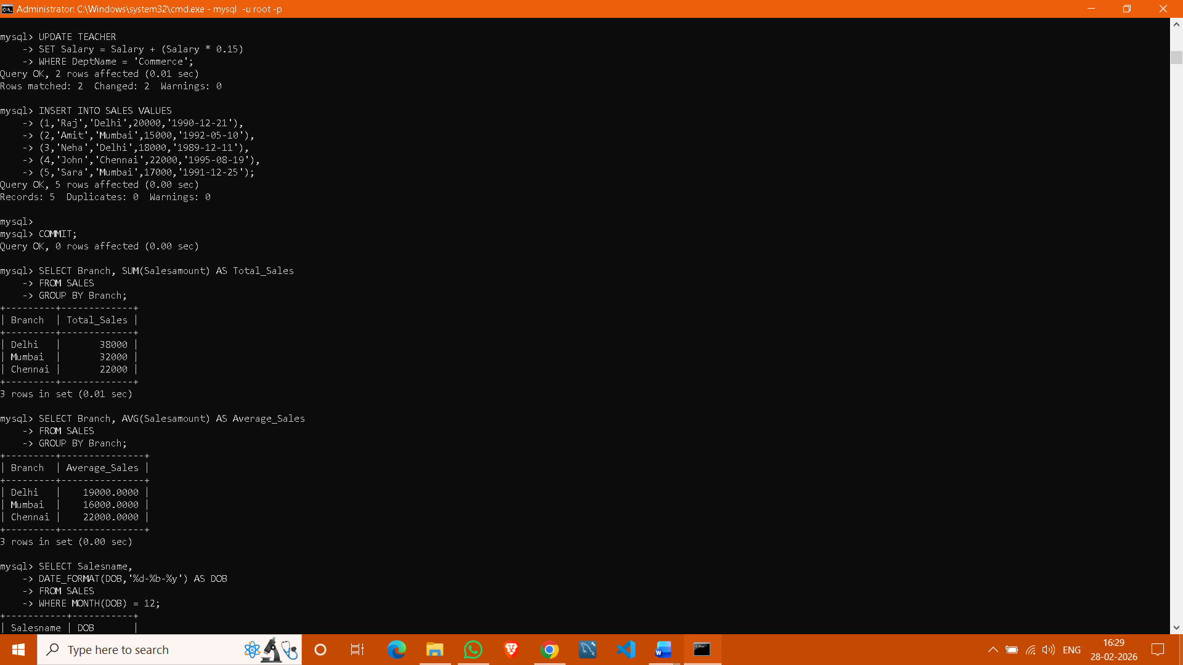

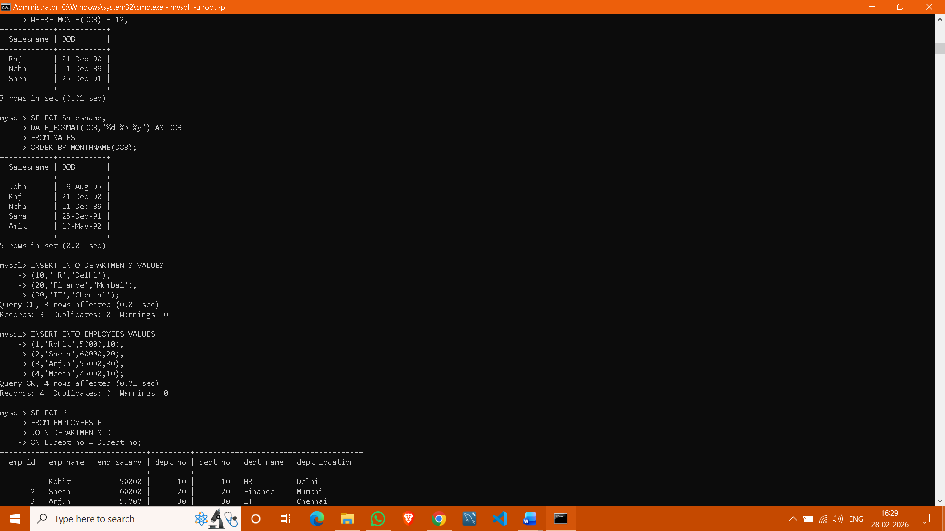
From JOIN Operations

- Display employee details and department details where the department numbers are the same in both tables.
- Display the employee name and department name using a LEFT OUTER JOIN.
- Display the employee name and department name using a RIGHT OUTER JOIN.
- Display the details of employees who draw a salary greater than the average salary.


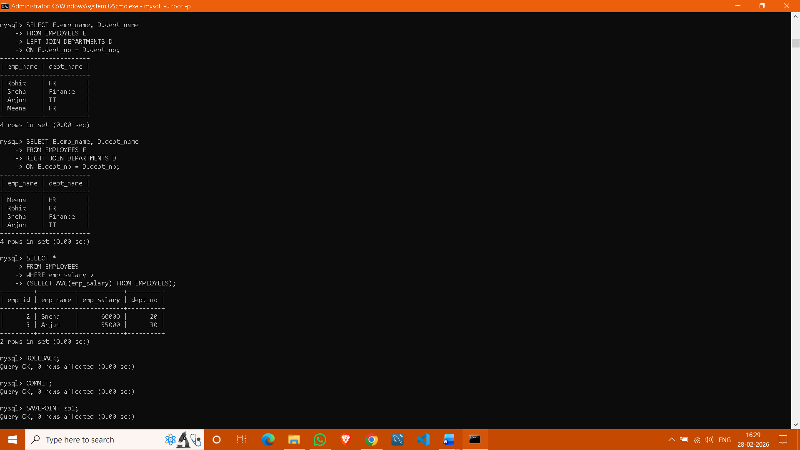

TCL Questions (Transaction Control Language)

- Perform the ROLLBACK command on the TEACHER table.
- Perform the COMMIT command on the TEACHER table.
- Write a query to implement a SAVEPOINT.

DCL Questions (Data Control Language)

- Write a query to grant all privileges on the EMPLOYEES table to DEPARTMENTS.
- Write a query to grant selected privileges on the EMPLOYEES table to DEPARTMENTS.
- Write a query to revoke all privileges on the EMPLOYEES table from DEPARTMENTS.
- Write a query to revoke selected privileges on the EMPLOYEES table from DEPARTMENTS.

